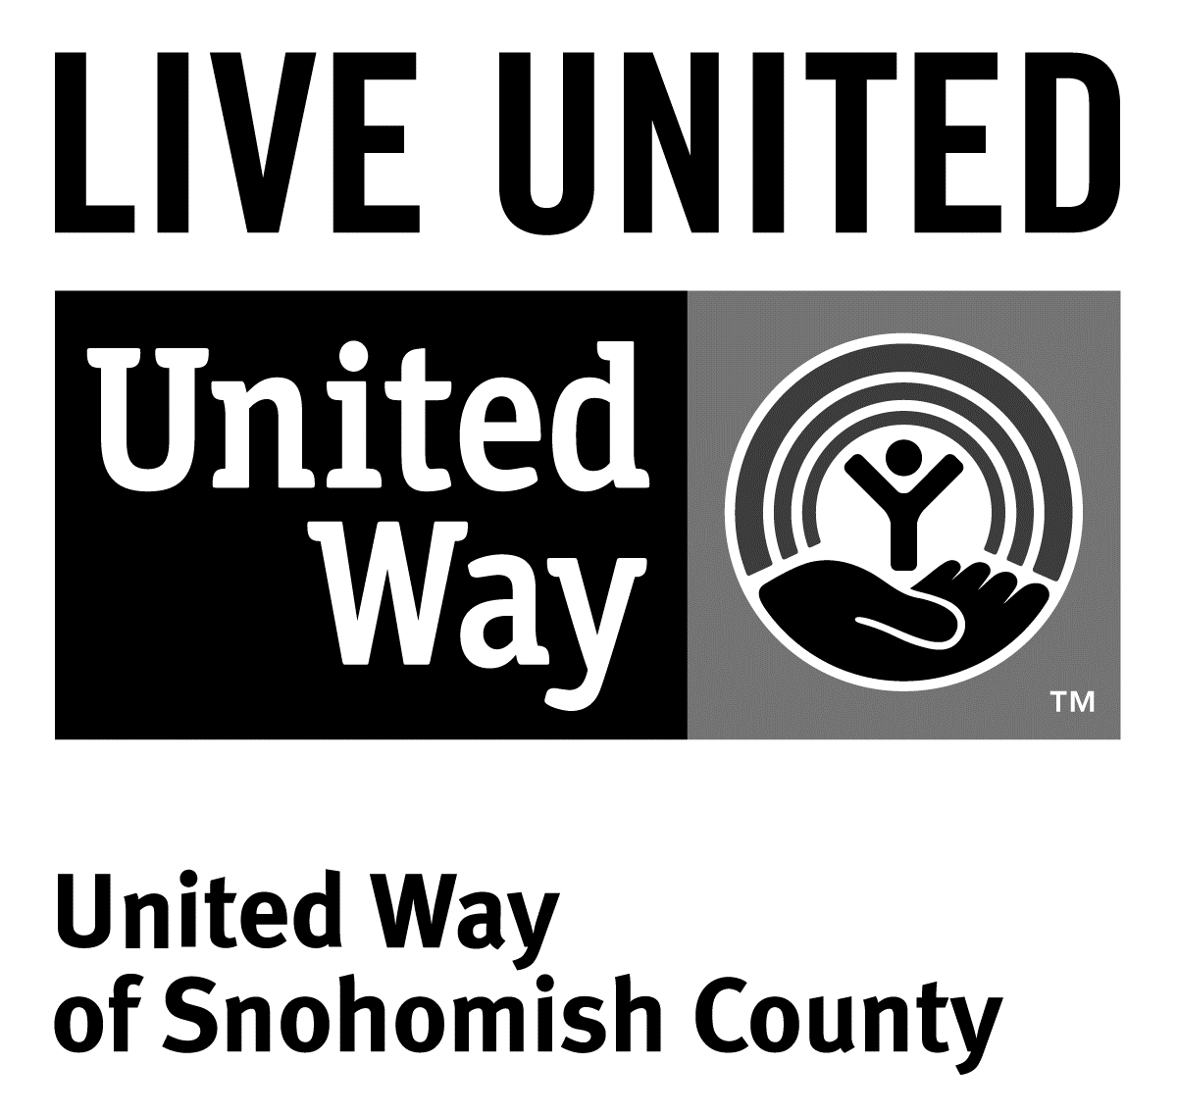
3120 McDougall Ave., Ste. 200
Everett, WA 98201
Ph: 425.374.5500
F: 425.374.5555

FOR IMMEDIATE RELEASE
February 4, 2015

CONTACT
Neil Parekh 206.370.0058; neil.parekh@uwsc.org
Vice President of Marketing and Communications, United Way of Snohomish County

Karri Matau (425.212.4056); karri@greatereverettcf.org
Vice President of Philanthropic Services, Greater Everett Community Foundation

United Way and Greater Everett Community Foundation work together to address intergenerational poverty
(Everett, Wash.) -- Twenty local nonprofits will receive $160,000 in capacity-building grants from United Way of Snohomish County and Greater Everett Community Foundation in 2015 to help address intergenerational poverty in Snohomish County. This is the second year that each agency has supported this work and the first time they approached the decision making through a joint process.

“Since we were doing similar work, we decided to coordinate our efforts this year,” said Dennis Smith, president and CEO of United Way of Snohomish County. “It’s been a great partnership. We are thrilled with this year’s capacity building grantees,” he added.

“These nonprofits will get the benefit of working with both of us,” said Maddy Metzger-Utt, president of the Greater Everett Community Foundation. “Our overall goal is to strengthen our community and help these nonprofits do a better job of providing services for their clients.”

The two agencies will jointly offer technical support, training and opportunities for grant recipients to collaboratively identify solutions to common problems. Funding for capacity-building projects and staff training will eventually help more Snohomish County families escape intergenerational poverty.

Recipients of the funding are taking a variety of approaches to long-term capacity building:

- Academic Link Outreach will use their $4,400 grant to improve the capacity of its board of directors.

- Arlington Kids Kloset will use their $5,000 grant to develop and maintain a new website.

- Community Resources Foundation will use their $10,000 grant to support its volunteer center.

- Everett Recovery Café will use their $5,448 grant to make it possible for the Café to open its doors and begin operations by hiring a floor manager.

- Farmer Frog will use their $10,000 grant to upgrade and build out their website.

- Foundation for Edmonds School District will use their $5,387 grant to upgrade their database and improve their online giving portal.

- Granite Falls Family Support Center will use their $8,900 grant to increase their fundraising capacity and develop a fundraising plan.

- Greater Trinity Academy will use their $10,000 grant to contract with a grant writer, upgrade their computer lab, expand their STEM curriculum and offer computer access and training.

- Hand in Hand will use their grant $10,000 to fund a staff person who will manage volunteers and work with local service providers.

- Housing Consortium of Everett and Snohomish County will use their $7,768 grant to purchase computer hardware and software and work with a professional grant writer.

- Interfaith Association of Northwest Washington will use their $10,000 grant to conduct an internal evaluation to determine more efficient, sustainable and creative ways to serve homeless and low-income families.

- Integrative Psychological and Social Services will use their $3,188 grant to train staff who work with underinsured and uninsured clients.

- Lake Stevens Family Center will use their $8,200 grant to increase technical data reporting capabilities to generate reports that quantify the positive family/community impact of their work.
- Latino Educational Training Institute will use their $9,656 grant to expand English language instruction and create a computer skills training center.

- Mari’s Place will use their $9,200 grant to purchase computers, software and contract for accounting services and grant writing.

- Monroe Public Schools Foundation will use their $9,960 grant to increase their fundraising capacity, establish a donor database and improve their marketing materials.

- North Counties’ Family Services will use their $8,500 grant to provide board and staff training, a community stake holders' workshop and help support a part-time Human Resources Manager as well as facilities/equipment support.

- Safe Harbor Free Clinic will use their $6,320 grant to pay for professional financial reviews and grant writing, staff and board training and attendance at conferences.

- Snohomish County Legal Services will use their $10,000 grant to hire a part-time Development Coordinator to work on private grants and individual giving and contract with a local accounting firm for quarterly reviews of their books.

- Take the Next Step will use their $8,000 grant to contract "Database Sherpa," an organization that guides, mentors and assists nonprofits in setting up a Salesforce database.

Decisions were based on demonstrated need and readiness for capacity building, total available dollars, and whether investment in the project was deemed the best way to achieve the greatest impact.

Details about the next round of capacity-building funding will be released later this year.

# # #

The Greater Everett Community Foundation works in partnership with donors and organizations to strengthen communities throughout Snohomish County. The Community Foundation promotes charitable giving and creates community impact through grantmaking. They also offer training and workshops to local nonprofits to help improve their effectiveness. To learn more about Greater Everett Community Foundation’s work in our community, visit their website at greatereverettcf.org.

United Way is a community impact organization serving Snohomish County for more than 70 years. In addition to funding 107 programs through 40 agencies with a special focus on local health and human services, United Way of Snohomish County supports a number of initiatives focusing on early learning and education, financial stability for families, a youth program, North Sound 211 and an emerging initiative in survival English. To find out more about United Way of Snohomish County, including how you can find help, how to volunteer and how United Way serves our community, visit their website at uwsc.org.

