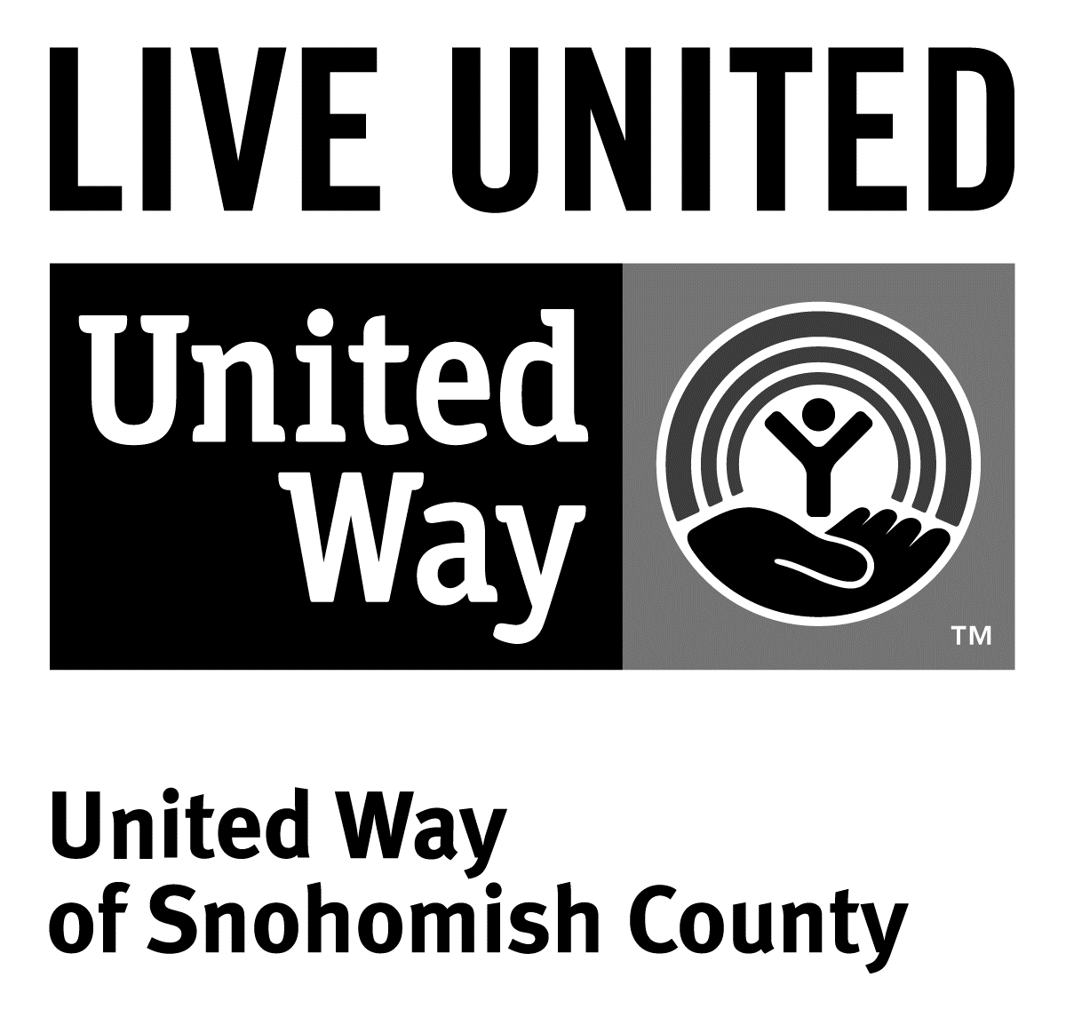3120 McDougall Ave., Ste. 200  
Everett, WA 98201

Ph: 425.374.5500

F: 425.374.5555

**Contact**

Neil Parekh 206.370.0058; [**neil.parekh@uwsc.org**](mailto:neil.parekh@uwsc.org)

Vice President of Marketing and Communications, United Way of Snohomish County

**United Way thanks 13,000 donors, 300 workplaces;   
honors award-winning campaigns**

(Everett, WA) – Senior Aerospace Absolute Manufacturing won the President’s Award and Jeff Roe, CEO of Premera Blue Cross won Executive of the Year as more than 500 representatives of Snohomish County companies, nonprofits, school districts, labor unions and government agencies celebrated the close of United Way of Snohomish County’s Community Caring Campaign.

The raised funds support 106 multi-year grants. The grants address both immediate needs in the priority investment areas that were identified by community members, and long-term solutions through United Way initiatives that focus on education, financial stability and English language learners.

“2014 was a deeply moving year for Snohomish County with the devastating mudslide last March and the school shooting in October,” said Dr. Dennis Smith, president and CEO of United Way of Snohomish County. “As often happens in such circumstances, however, these challenges brought out the best in our community: generosity and resiliency.”

“In fact, 13,000 individuals from 300 workplaces contributed to this year’s campaign,” he added.

Senior Aerospace Absolute Manufacturing of Arlington won the top award — in part for almost doubling the money they raised for their campaign, tripling their corporate gift and tripling employee participation. Several of their employees live in Darrington, which made choosing to do their Days of Caring project at the Darrington Community Center an easy decision. Absolute staff member Trina Massingale also won an Employee Campaign Manager of the Year Award.

Jeff Roe, president and CEO of Premera Blue Cross, won United Way’s top individual award: Executive of the Year. Roe, despite transitioning into his new role and replacing Premera’s former CEO Gubby Barlow just as the campaign started, was was unstoppable. He gave the campaign his full support, joining United Way’s Tocqueville Society and board of directors. Premera, which set the record for largest workplace campaign last year set a new record in 2014 by raising $645,000.

“I am proud to say that United Way received support from throughout the entire county,” said Jerry Goodwin, United Way’s 2014 campaign chair and CEO of Senior Aerospace. “We built community together by working with large corporations; small, family-owned businesses, nonprofits; government agencies and labor unions.”

Other notable award winners included Marysville School District Campaign Team and Umbra Cuscinetti, Inc.

The Labor Partnership Award went to a coalition of groups involved in the Marysville School District campaign. They put their United Way campaign on hold temporarily after the tragic shooting at Marysville-Pilchuck High School last October, but decided that one way to help the community move forward was to come together and finish the campaign.

The Best New Campaign Award went to Umbra Cuscinetti, an aerospace company. They reached 20 percent participation in their first year, matched all employee gifts 100 percent, sponsored an Aerospace Golf Scramble and raised money for United Way’s Disaster Recovery Fund for Mudslide Relief.

The United Way Community Caring campaign includes contributions to the various United Way campaigns, the Combined Federal Campaign and the Employees Community Fund of Boeing Puget Sound. The largest, single contributions come in the form of grants from the Employees Community Fund of Boeing Puget Sound ($1.86 million) and The Boeing Company ($725,000).

Platinum event sponsors included AT&T and The Boeing Company. Premier event sponsors included The Everett Clinic, Jamco America, Inc. and Union Bank. Presenting sponsors included Fluke Corporation, Providence Regional Medical Center Everett, Puget Sound Energy and Tulalip Resort Casino. Media and in-kind sponsors included The Daily Herald, Microsoft, GoodSide Studio and Stadium Flowers.

United Way of Snohomish County will be celebrating its 75th anniversary in 2015. Josh O’Connor, publisher of The Herald, and Larry Hanson, publisher emeritus, will co-chair United Way’s 2015 campaign.

Social media posts from the event can be found at [www.tagboard.com/UWSC_CCC](http://www.tagboard.com/UWSC_CCC).

Here is a full list of award winners:

**President’s Award**

Senior Aerospace Absolute Manufacturing

**Executive of the Year Award**

Jeff Roe of Premera Blue Cross

**Employee Campaign Manager of the Year Awards**

Debbie Beaman, Kimberly Rashid and Dena Searcy of Comcast

Heidi Burgi and Trista Fure of Community Health Center of Snohomish County

Trina Massingale of Senior Aerospace Absolute Manufacturing

Britta Schwendtke of The Arc of Snohomish County

Diane Broderick from The Bank of Washington

**Premier Partner Award**

The Boeing Company

Employees Community Fund of Boeing Puget Sound

**Labor Partnership Award**

Marysville School District Campaign Team

**LIVE UNITED Award**

Jamco America, Inc.

**Positive Change Award**

Pandora Jewelry

**Best New Campaign**

Umbra Cuscinetti, Inc.

###

United Way is a community impact organization serving Snohomish County for more than 70 years. In addition to funding 106 programs through 40 agencies with a special focus on local health and human services, United Way of Snohomish County supports a number of initiatives focusing on early learning and education, financial stability for families, a youth program, North Sound 211 and an emerging initiative in survival English.

To find out more about United Way of Snohomish County, including how you can find help, how to volunteer and how United Way serves our community, visit their website at uwsc.org.