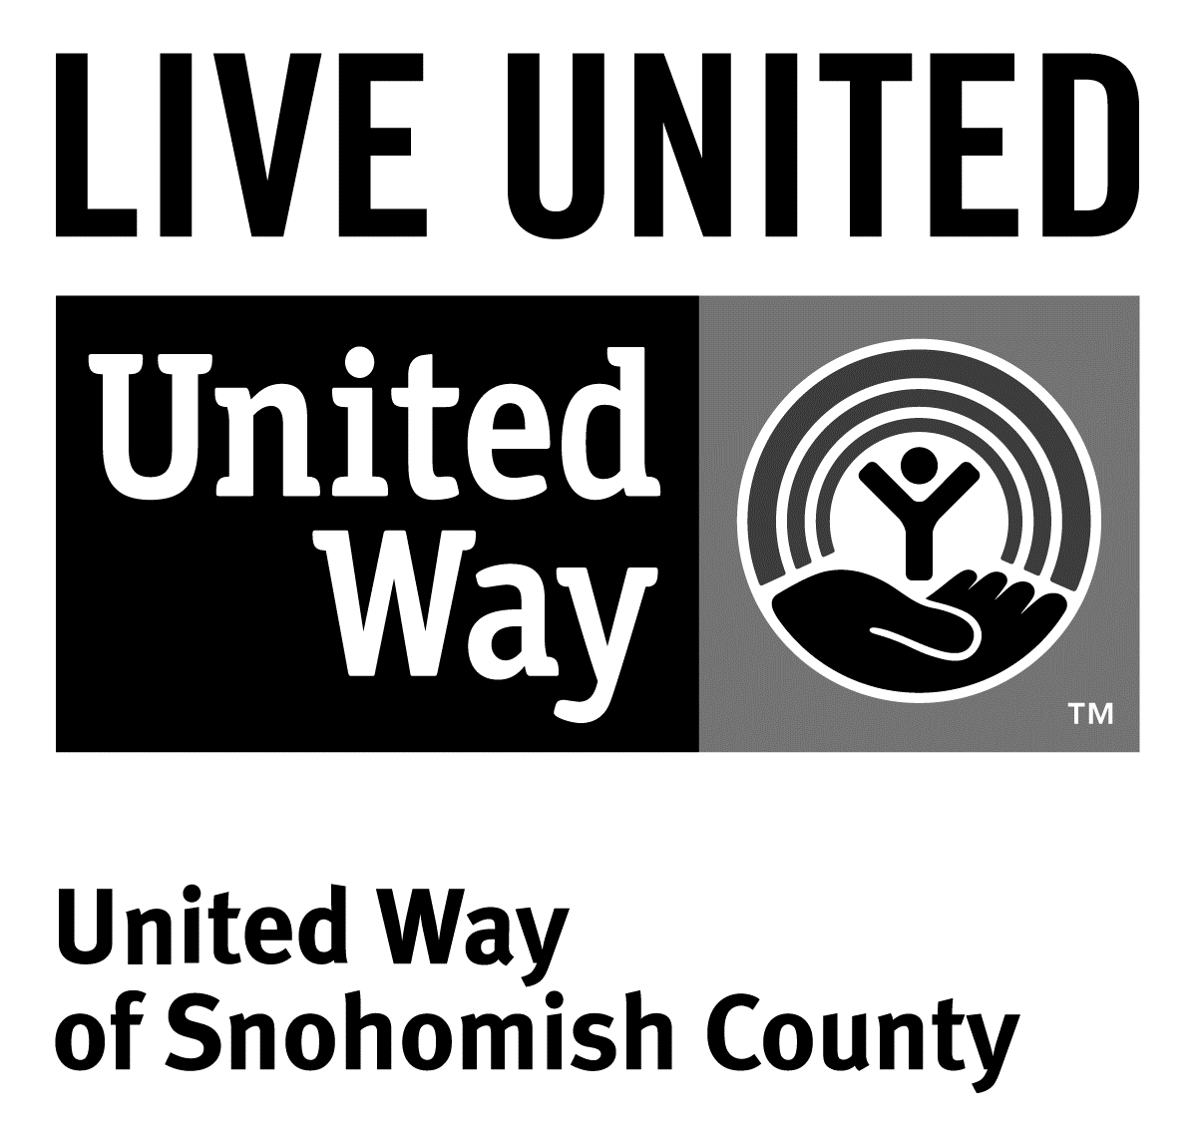
3120 McDougall Ave., Ste. 200
Everett, WA 98201
Ph: 425.374.5500
F: 425.374.5555

FOR IMMEDIATE RELEASE
April 16, 2015

Contact
Sara Haner 206.714.3304; sara.haner@uwsc.org
Communications and Events Manager, United Way of Snohomish County

Governor Jay Inslee to honor Everett resident with Volunteer Service Award

(Everett, Wash.) -- In a ceremony at the governor’s mansion on Tuesday, April 21, Governor Inslee will present awards to this year’s Volunteer Service Award honorees. Jackie Rae of Everett is one of dozens being honored with this prestigious award.

Jackie was nominated by United Way of Snohomish County, and is being recognized for her outstanding volunteer work in Snohomish County and within the labor community.

If there’s a large-scale volunteer project taking place in Snohomish County, it’s a safe bet that Jackie Rae is somehow involved. From her work with the annual Toys for Tots drive and Letter Carriers Food Drive, to her involvement with ramp building projects throughout the county, Jackie Rae is one of Snohomish County’s most dedicated volunteers. She believes that Snohomish County should be a healthy and safe community, and works hard to make that vision a reality.

Jackie’s labor involvement includes her service on the Snohomish County and Washington State Labor Councils. On these councils, she serves on the education and women’s committees, supporting issues of special concern to working women and granting scholarships to young people coming into the trades.

As an employee of Snohomish County Public Utility District (PUD), Jackie is a union member and unit financial officer of the International Brotherhood of Electrical Workers (IBEW) Local 77. Additionally, she is currently the union representative for PUD's charitable giving program in partnership with IBEW 77, and served the union as a political liaison during the 2012 election cycle.

Jackie is also an active volunteer with United Way of Snohomish County, serving on its board of directors. She is also a frequent advocacy volunteer with the organization, participating in annual lobby day events. County-wide, Jackie volunteers with Project Homeless Connect, and serves on the Boundary Review Board for Snohomish County.

Jackie’s family has lived in the Everett area for decades, and she still calls Everett home. When she isn’t volunteering, she loves spending time with her two daughters and three grandchildren.

Last year, United Way mobilized 2,424 individual volunteers for the community. They contributed 19,161 hours of volunteer time to 267 nonprofits, many of them finding their projects online at uwsc.org/volunteer.php, United Way of Snohomish County’s online database of volunteer opportunities.

# # #

United Way is a community impact organization serving Snohomish County for 75 years. In addition to funding 106 programs through 40 agencies with a special focus on local health and human services, United Way of Snohomish County supports a number of initiatives focusing on early learning and education, financial stability for families, a youth program, North Sound 211 and an emerging initiative in survival English.
To find out more about United Way of Snohomish County, including how you can find help, how to volunteer and how United Way serves our community, visit their website at uwsc.org.

