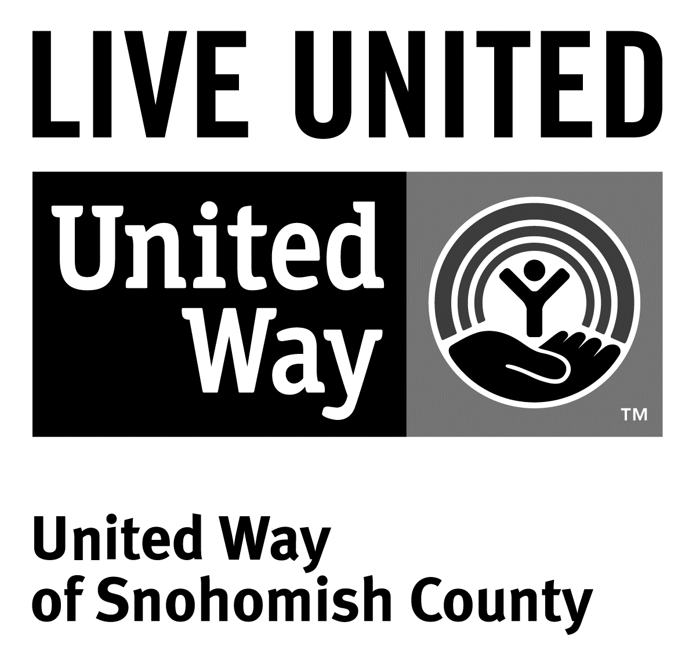
3120 McDougall Ave., Ste. 200
Everett, WA 98201
Ph: 425.374.5500
F: 425.374.5555

FOR IMMEDIATE RELEASE
May 11, 2015

Contact
Sara Haner, 425.374.5519 | sara.haner@uwsc.org
Communications and Events Manager, United Way of Snohomish County

United Way of Snohomish County awards $50,000 in financial education grants
(Everett, Wash.) – Seven local nonprofits have been selected as recipients of United Way of Snohomish County’s financial education grants. Totaling $50,000, these funds were provided by The Boeing Company and recipients were selected by United Way’s Families Matter Vision Council.
Funding from these grants will be used by the organizations to provide financial education to youth, seniors, low-income families and small business owners in Snohomish County.
This year’s grant recipients include Arlington Resource Center ($4,706), Boys & Girls Club of Snohomish County – Everett Club ($3,028), Financial Beginnings ($7,000), Housing Hope ($11,638), Lake Stevens & Granite Falls Family Support Centers ($5,769), Senior Services of Snohomish County ($7,859) and Washington C.A.S.H.($10,000).
In addition to awarding these grants, preparing tax returns for free, encouraging people to purchase U.S. Savings Bonds and providing other financial education programs are part of United Way’s overall effort to help Snohomish County families achieve and maintain financial stability.
###
United Way is a community impact organization serving Snohomish County for 75 years. In addition to funding 106 programs through 40 agencies with a special focus on local health and human services, United Way of Snohomish County supports a number of initiatives focusing on early learning and education, financial stability for families, a youth program, North Sound 211 and an emerging initiative in survival English.
To find out more about United Way of Snohomish County, including how you can find help, how to volunteer and how United Way serves our community, visit their website at uwsc.org.

