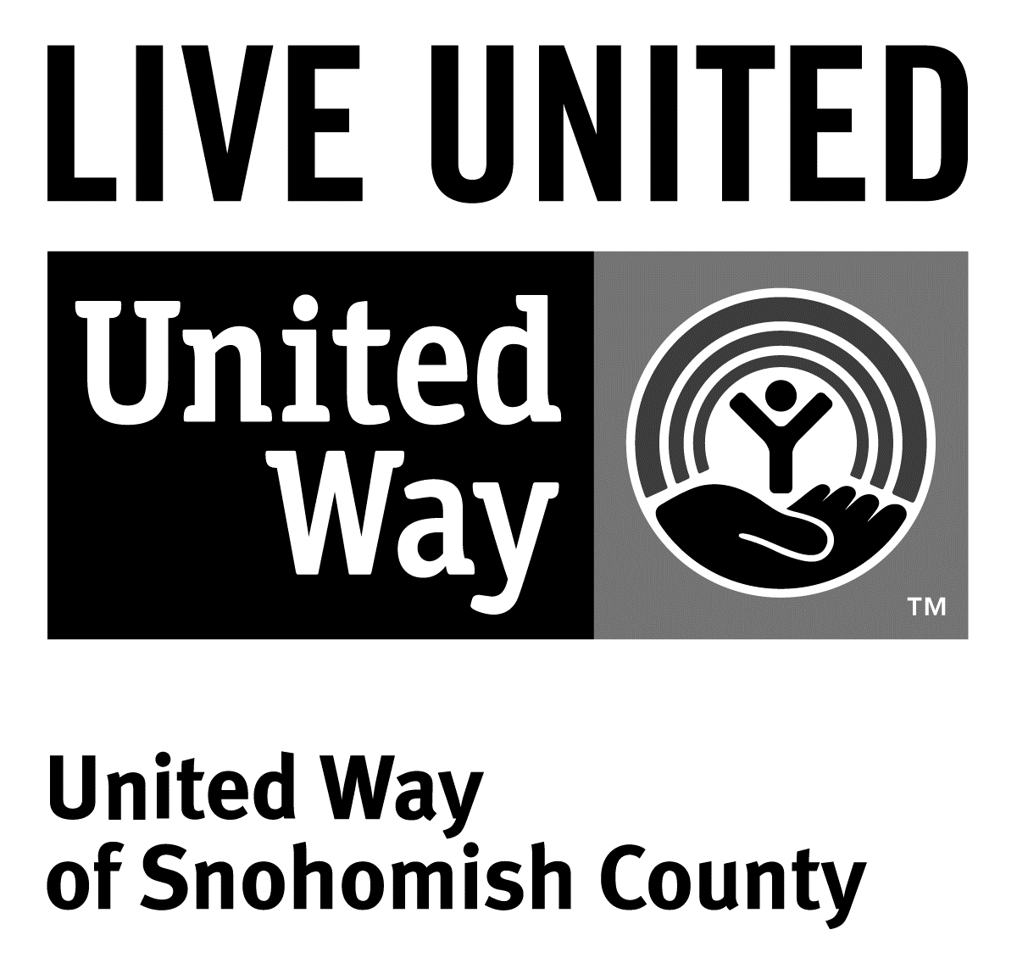
3120 McDougall Ave., Ste. 200
Everett, WA 98201
Ph: 425.374.5500
F: 425.374.5555

FOR IMMEDIATE RELEASE
July 15, 2016

Contact
Jacqui Campbell, 425.374.5501 | jacqui.campbell@uwsc.org
Director of Marketing and Communications, United Way of Snohomish County

Project Homeless Connect provides services to
933 at day-long event
(Everett, Wash.) – Before the doors opened at 9 a.m. for this year’s Project Homeless Connect, there was already a line out the door. As the event began, hundreds of guests streamed into Everett High School in Everett to access services like foot care, dental checkups, and haircuts.
All told, 933 individuals were served by the eighth annual Project Homeless Connect in Snohomish County, a one-day event providing free direct services to families and individuals experiencing homelessness or at risk of becoming homeless.
Project Homeless Connect builds on a national model to deliver immediate services and to improve long-term access to services. Begun in Snohomish County in 2008, this event is a collaboration among Snohomish County Human Services Department, United Way of Snohomish County, Snohomish Health District, City of Everett, multiple nonprofits, and volunteers. This year’s leading sponsor is the Employees Community Fund of Boeing Puget Sound. We also received funding and support from Snohomish County, the City of Everett, Everett Transit, United Way of Snohomish County. Everett School District hosted us again, this year at Everett High School’s Norm Lowery Gymnasium. Other in-kind resources were provided by Electronic Business Machines and Starbucks Corporation.
101 services were offered to help meet basic needs and connect individuals and families to resources. Of the approximately 930 attendees, 181 were children under the age of 18. 140 pets received services, as well, from Everett Animal Shelter.
During the registration process, guests were asked about their housing situation. Of those responding to these questions, 56% reported they currently do not have stable housing, meaning that they do not have a consistent place to live (living in a car, on the street, or couch surfing). 21% reported they are currently staying in a shelter or transitional housing. Additionally, 10% of participants reported they were eligible for VA benefits, but only 39% are receiving them.
Everett Gospel Mission organized the meal service this year. Guests were seated and served by volunteers in a restaurant setting, and given a choice of appetizers and hot entrees. This table service is a hallmark of the event, and something that guests look forward to.
Guests at the event also had the option of receiving a backpack with toiletries, a new pair of sneakers, a family portrait, immunizations, taking a shower, washing their clothes on-site and more. There was also child care available on-site.
Project Homeless Connect can be found online at www.uwsc.org/phcsnoco, on Facebook at Project Homeless Connect - Snohomish County and on Twitter at @phcsnoco.
# # #

