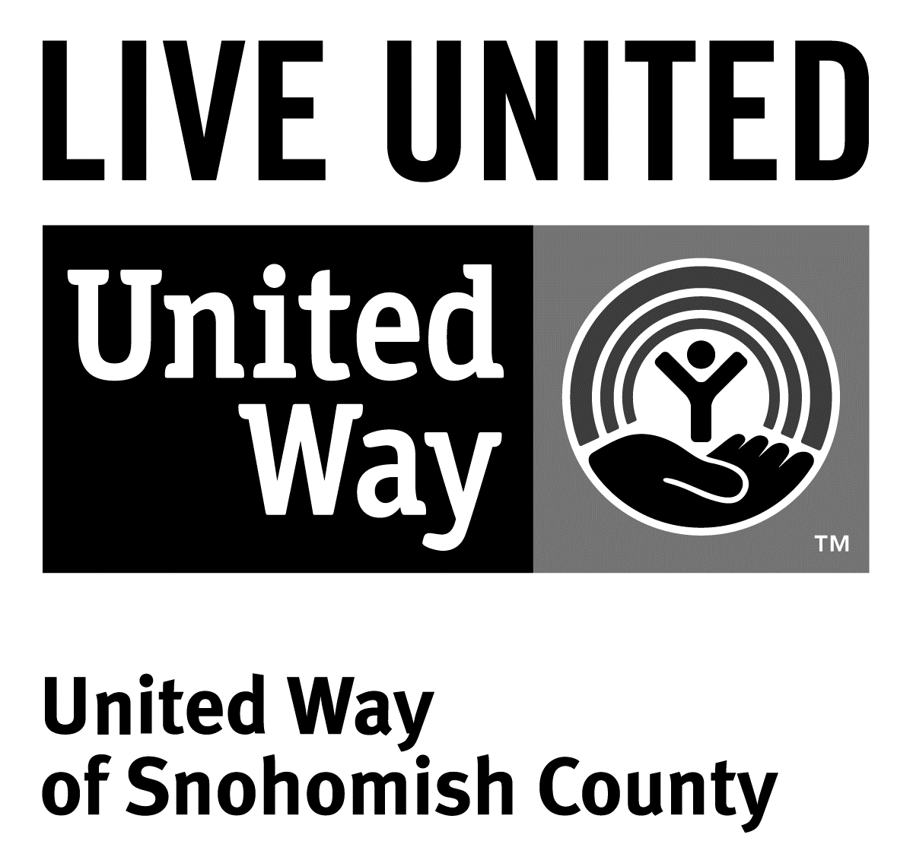
3120 McDougall Ave., Ste. 200
Everett, WA 98201
Ph: 425.374.5500
F: 425.374.5555

FOR IMMEDIATE RELEASE
Sept. 1, 2015

Contact
Sara Haner, 425.374.5519 | sara.haner@uwsc.org
Communications and Events Manager, United Way of Snohomish County

Working Better Together to Address Poverty in Snohomish County
(Everett, Wash.) – This month, United Way of Snohomish County, Snohomish County Human Services Department, several civic organizations and other nonprofit leaders are holding a summit aimed at beginning the conversation about working better together to address poverty in our community.
The goal of the summit is to learn about working collectively, as well as share insights about work already occurring in the community. The gathering will be the first step in creating a greater network of addressing poverty-related issues in the county.
“There are over 100 organizations addressing poverty-related issues in our community, and they don’t always know about each other’s efforts,” says Mary Jane Brell Vujovic, Human Service Director of Snohomish County and an organizer of the summit. “This summit will help make sure we’re all on the same page, and move forward collectively.”
Summit organizers believe that poverty is a complicated issue and addressing it successfully requires careful collaboration. “If we work together, we can make a real difference in Snohomish County,” Vujovic says.
This summit will be the first in a series of conversations about how to tackle issues surrounding poverty and homelessness using a collective impact approach.
###
United Way is a community impact organization serving Snohomish County for 75 years. In addition to funding 106 programs through 40 agencies with a special focus on local health and human services, United Way of Snohomish County supports a number of initiatives focusing on early learning and education, financial stability for families, a youth program, North Sound 211 and an emerging initiative in survival English.
To find out more about United Way of Snohomish County, including how you can find help, how to volunteer and how United Way serves our community, visit their website at uwsc.org.

