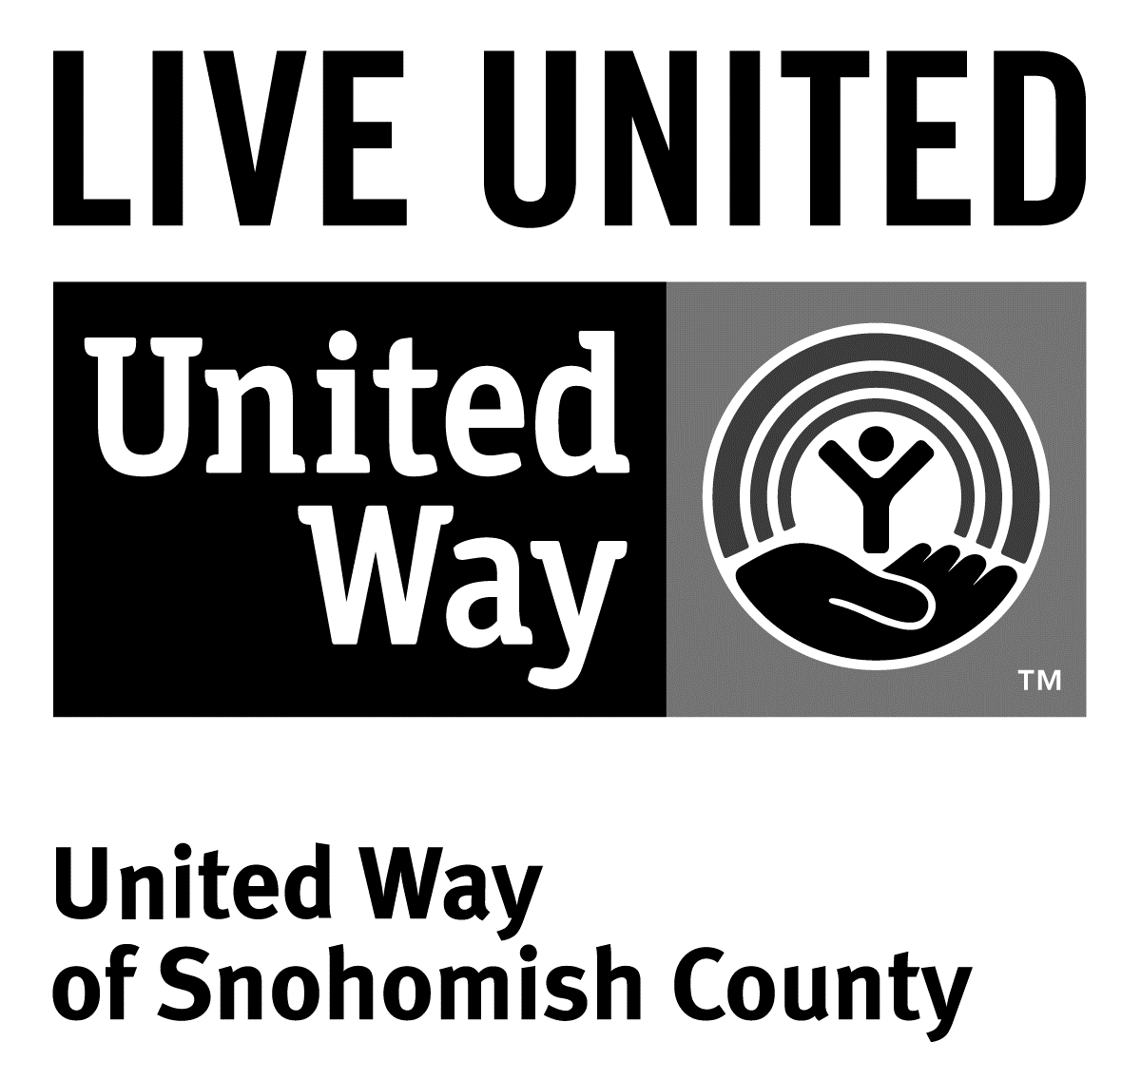
3120 McDougall Ave., Ste. 200
Everett, WA 98201
Ph: 425.374.5500
F: 425.374.5555

FOR IMMEDIATE RELEASE
September 25, 2015

CONTACTS

Sara Haner (206.714.3304) sara.haner@uwsc.org Communications and Events Manager, United Way of Snohomish County

Spirit of Snohomish County Award Winners Announced

(Everett, Wash.) —On Thursday, Sept. 24, United Way of Snohomish County announced its annual Spirit of Snohomish County award winners; individuals that have been dreaming big and making their mark on the county this year. Additionally, the event welcomed keynote speaker Stacey Stewart, U.S. President of United Way Worldwide.
Spirit of Giving Award: Debra Warden and Steve Kohlmyer
When Debra Warden and Steve Kohlmyer decided to give to the United Way endowment, they didn’t have to think twice. “It just made sense,” Deb says about their decision. “It’s a perfect way to give to our community, but in a lasting way.” In addition to the endowment, the couple also gives back to their community through United Way’s Tocqueville Society, a national association created to celebrate individuals who demonstrate exceptional philanthropic leadership. To Debra and Steve, giving means more than just donating their treasure; they also give their time and talents to Snohomish County. The pair volunteers throughout the year, most recently at Project Homeless Connect and the Letter Carriers Food Drive.
Spirit of Advocacy Award: Jim and Tiffany Litz
For the past five years, this father/daughter team has been an important part of United Way’s annual Lobby Day in Olympia. Working together, Jim and Tiffany meet with legislators to share issues that are important to United Way. “Advocating for United Way is eye-opening. It’s a unique way to support your community, while getting a glimpse behind the scenes in Olympia,” says Jim—who in addition to advocacy work—has served for many years on United Way’s marketing committee, as well as board chair in 2012. Advocating for United Way together, Jim and Tiffany have helped pass several pieces of legislation supporting both 2-1-1, and people experiencing homelessness and poverty in our community. “Lobbying for United Way is important to me,” says Tiffany. “The representatives and senators that we meet with take United Way’s voice seriously.” On volunteering with her dad, Tiffany says “I love volunteering with my dad; I look up to his service!”
Spirit of Volunteering Award: Greg and Emily Hinrichs
As soon as Greg started dating Emily years ago, he knew service would become a big part of his life. “I’m involved in everything! Serving is such a big part of who I am.” Emily says. And it’s true; beginning her volunteering with United Way of Snohomish County in 1997, Emily was a founding member of the Kids Matter Vision Council. As she and Greg grew closer and eventually married, the two could be found at every United Way volunteer event. Today, both serve hundreds of hours each year on the Kids Matter Vision Council, at their church and local food banks. To both, service has always been a way of life. When they moved to Marysville, they actively sought out ways to serve and become involved in their new community. “You get out of your community what you put into it, and that’s why we serve,” says Greg. “You can do more together than you can apart.”
Spirit of Labor Award: Jackie Rae
If there’s a large-scale volunteer project taking place in Snohomish County, it’s likely Jackie is involved. From her work with the annual Toys for Tots Drive and Letter Carriers Food Drive, to her involvement with ramp building projects throughout the county, Jackie is one of Snohomish County’s most dedicated labor volunteers. She serves on the Snohomish County and Washington State Labor Councils and is an employee of Snohomish County Public Utility District, where she is a union member and unit financial officer of the International Brotherhood of Electrical Workers Local 77. Jackie is also an active volunteer with United Way of Snohomish County, serving on its board of directors. She frequently volunteers as an advocate for United Way, participating in annual lobby day events. County-wide, she volunteers for Project Homeless Connect, and serves on the Boundary Review Board for Snohomish County.
Reeves/Sievers Founders’ Award: Mike Sells
Mike Sells’ career in public service has run the gamut from education to elected office. He served as an educator for 30 years in Everett Public Schools, and has served as President of the education association. For many years, Mike also sat on the Everett Housing Board and United Way of Snohomish County’s board of directors. Since 2004, Mike has served in the Washington State House of Representatives, where he is chair of the Labor and Workforce Development Committee. Perhaps Mike’s most impactful role has been his 37 years as of service as the Secretary-Treasurer of the Snohomish County Labor Council. The organization is the coordinating body for 65 different AFL/CIO unions in Snohomish County, representing more than 42,000 working people. In this role, Mike has been instrumental in creating labor engagement work between United Way and the labor community. As a result, today, United Way and local unions work together on many projects, including ramp building, Toys for Tots, the Letter Carriers Food Drive, and more. Though Mike recently retired from his position at the Labor Council, his service has been indelibly stamped upon Snohomish County.
Keynote Speaker: Stacey Stewart, U.S. President of United Way Worldwide
As U.S. President of United Way Worldwide, Stacey Stewart leads the strategic direction for United Way in the U.S., working with leaders to drive community impact. Before joining United Way, Stacey was Chief Diversity Officer and Senior Vice President for the Office of Community and Charitable Giving at Fannie Mae. She speaks passionately about impact and collaboration, and about how, by working together, we can address the biggest challenges facing our community.
# # #
United Way is a community impact organization serving Snohomish County for 75 years. In addition to funding 106 programs through 40 agencies with a special focus on local health and human services, United Way of Snohomish County supports a number of initiatives focusing on early learning and education, financial stability for families, a youth program, North Sound 211 and an emerging initiative in survival English.
To find out more about United Way of Snohomish County, including how you can find help, how to volunteer and how United Way serves our community, visit their website at uwsc.org.

