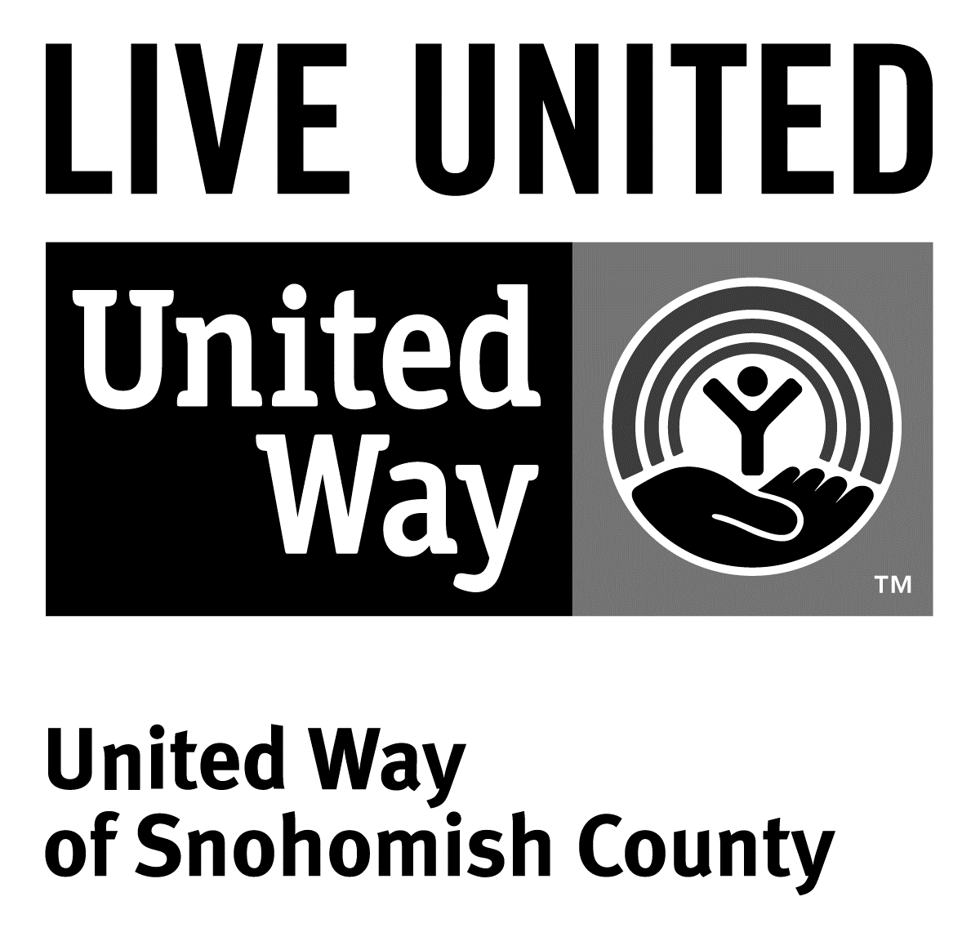
3120 McDougall Ave., Ste. 200
Everett, WA 98201
Ph: 425.374.5500
F: 425.374.5555

FOR IMMEDIATE RELEASE
Nov 3, 2015

Contact
Jacqui Campbell, 425.374.5501 | jacqui.campbell@uwsc.org
Director of Marketing and Communications, United Way of Snohomish County

Working Better Together to Address Poverty in Snohomish County
(Everett, Wash.) – On November 18th, United Way of Snohomish County, Snohomish County Human Services Department, several civic organizations and other nonprofit leaders are holding a second summit at the Lynnwood Convention Center from 9am – 4pm to continue conversations about working better together to address issues related to poverty in our community.
The purposes of this second gathering are to take the next steps toward working collectively throughout Snohomish County, and to build a greater network of everyone addressing poverty-related issues.
“This summit will help to further our discussions on this important issue, and help make sure we’re all on the same page so we can move forward collectively,” says Mary Jane Brell Vujovic, Human Service Director of Snohomish County and an organizer of the summit. “If we work together, we can make a real difference in Snohomish County.”
This summit will dive deeper into the root causes of poverty including: education, health, law/justice and housing and how using a collective impact approach can help work towards a solution.
For more information, visit http://www.uwsc.org/povertyresourcelibrary.php or call 425.374.5501

###
United Way is a community impact organization serving Snohomish County for 75 years. In addition to funding 106 programs through 40 agencies with a special focus on local health and human services, United Way of Snohomish County supports a number of initiatives focusing on early learning and education, financial stability for families, a youth program, North Sound 211 and an emerging initiative in survival English.
To find out more about United Way of Snohomish County, including how you can find help, how to volunteer and how United Way serves our community, visit their website at uwsc.org.

