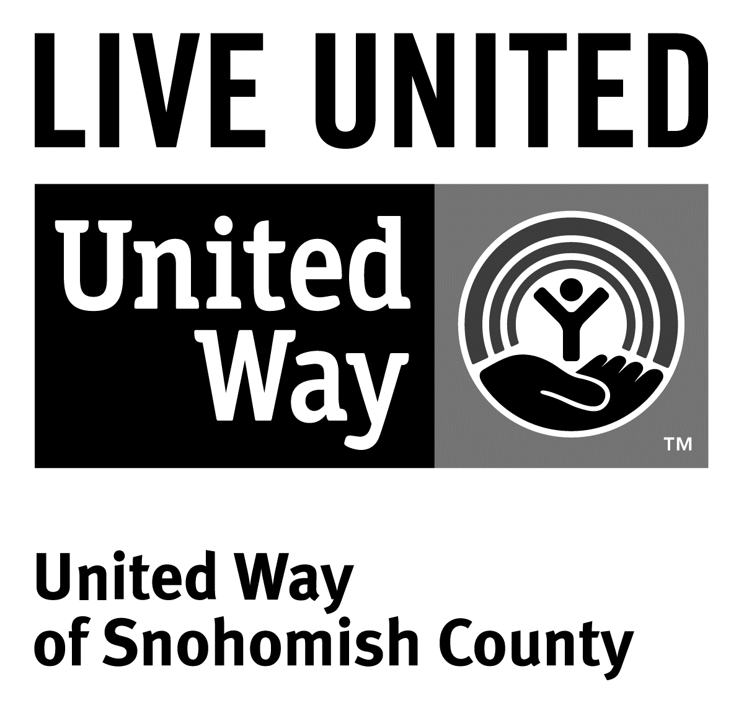
3120 McDougall Ave., Ste. 200
Everett, WA 98201
Ph: 425.374.5500
F: 425.374.5555

FOR IMMEDIATE RELEASE
September 9, 2016

CONTACTS

Makenzie Landis, Events and Communications Manager 425.374.5519

Spirit of Snohomish County Award Winners Announced

(Everett, Wash.) — On Thursday, Sept. 8, United Way of Snohomish County announced its annual Spirit of Snohomish County Award winners.
Change Maker Award: Trade UP

The Change Maker Award goes to an individual, project or organization that displays exceptional inspiration, passion, creativity and success in working to break the cycle of poverty. This year, the Change Maker Award went to the organization Trade UP. Trade UP was created as a collaboration between Snohomish County Labor Council, Workforce Snohomish and United Way. The program gives youth a hand-on experience with apprenticeship programs from the trades. Students get to operate equipment, handle tools and talk with professionals in the field, learning about wages, benefits and career pathways.

More than 100 students have already participated, and many different unions, local companies and organizations collaborated to put the program together. It is a true community-wide effort, which is inspiring our youth to consider good family-wage jobs, right here in our own backyard. The award was presented to Mayor Leonard Kelley of Stanwood.

Roger Bouck Award for Volunteerism in Action: Lynn A. Nixon

The Roger Bouck Award for Volunteerism in Action was created to honor volunteerism in Snohomish County. Lynn Nixon received the Roger Bouck Award. For the past 36 years, Nixon has put her heart and soul into volunteering throughout Snohomish County. For United Way alone, she has been a board member, served on funding and strategic planning committees, and was a 12-year member of the Community Matters Vision Council. She has also spent years volunteering for other organizations throughout our community. Some highlights have included the Future of Flight Foundation, Cocoon House, Hewlett-Packard National Contribution Board, Snohomish County Healthy Communities, Snohomish County Executive Citizens Cabinet and Governor Locke’s Digital Education Task Force.

Reeves/Sievers Founders’ Award: Helen R. Kendall and Dr. William Sanford
The Reeves/Sievers Founders’ Award is given to recognize a lifetime of community service and the spirit of philanthropy. This year, the award was presented to Helen R. Kendall and Dr. William Sanford. Kendall has been an active United Way of Snohomish County volunteer over the years, championing early learning work and spearheading United Way’s “Woman Leading the Way” initiative. Kendall is involved in many organizations throughout Snohomish County, including Domestic Violence Services of Snohomish County, Mukilteo YMCA, the Children’s Village Foundation and Zonta Club of Everett. Sanford is an active advocate for diversity and inclusion. While employed at The Boeing Company, he sat on their diversity council. Together, Kendall and Sanford have been major United Way supporters, members of United Way’s Tocqueville Society and have attended several international Tocqueville events.
The Boeing Company’s 100th Anniversary Recognition
The Boeing Company received an award recognizing their contribution to Snohomish County and to United Way. Since 2000, The Boeing Company and Boeing employees have donated more than $50 million to United Way of Snohomish County. Sam Whiting from The Boeing Company was presented the award.

Keynote Speaker: Dena Simmons
Dena Simmons is a lifelong activist, educator and student of life. A daughter of the Bronx, Simmons grew up in a one-bedroom apartment with her two sisters and immigrant mother.
Simmons has been a leading voice on teacher education and has written and spoken across the country about social justice pedagogy, diversity, education reform and bullying in K-12 school settings, including a TED talk.
# # #

United Way is committed to breaking the cycle of poverty in Snohomish County. United Way works with partners to improve education outcomes, reduce the number of struggling households and to ensure basic needs are met.

To find out more about United Way of Snohomish County, including how to give or volunteer, and how United Way serves our community, visit their website at www.uwsc.org.

