Email 1
Campaign Welcome and Kick-Off
From: Your United Way CEO/CPO, Board or Campaign Chair
Audience: All company employees
C2A: Give now to join the campaign
Image:

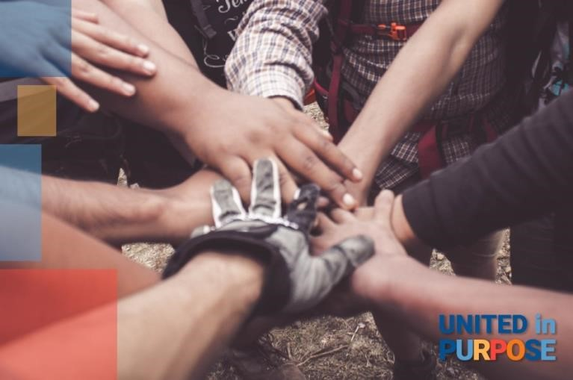

Subject line
Together, we are United in Purpose

Preheader text
When we are United, we can do more for United Way of Snohomish County

Body
Dear [First name],
Every day, United Way of Snohomish County brings people together to support communities where everyone can access a quality education, build economic mobility, and live a healthy life. Our work is powered by people, and local businesses like [company name] that are committed to supporting the strength, vitality, and resilience of our community.
This is not a regular campaign request. Joining United Way to be United in Purpose is a call to purposeful action. To be United in Purpose is to recognize and amplify our power to make a meaningful difference in the community where we work and live. It’s not just a one-time gift to a single issue that will resolve quickly, but a call to collaborate on the complex issues Snohomish County faces.
Here in Snohomish County we’re making a difference in thousands of people’s lives every year. By coming together to be United in Purpose, we can do so much more to accomplish goals that can change lives, like
- Creating access to early literacy for over 8,000 children age 0-5, through Dolly Parton’s Imagination Library. These FREE books are also positively and significantly associated with higher measures of early language and math development.

- Expanding access to dental care through a mobile dental clinic, including cleanings and the placement of sealants, for children who otherwise are uninsured and do not receive regular care.

- Assisting Snohomish County residents experiencing severe economic crisis, through the management of the Emergency Food and Shelter Program which puts dollars into our community for food, shelter, rent and utility assistance.

We only succeed when we collaborate and become United in Purpose with people like you who care about our community and collaborate with others to advance programs that meet urgent needs today while building strength for tomorrow.

Join us today. [Add link to donation landing page].
Closing,
Signature

BUTTON/CTA TEXT: BE UNITED IN PURPOSE

Email 2:
Why United Way?
From: Your United Way CEO/CPO, Board or Campaign Chair
Audience: All company employees
C2A: There’s still time to give now and join the campaign
Image:

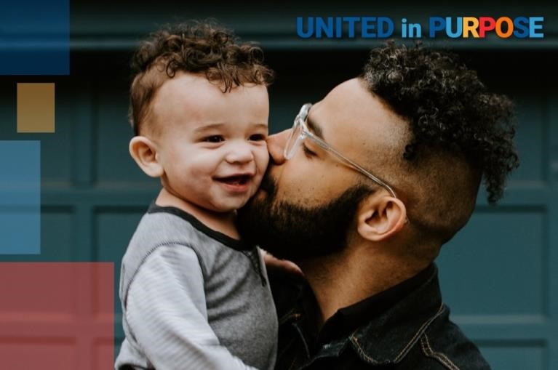

Subject line
What makes United Way of Snohomish County so special?

Preheader text
United Way is LOCAL, all over the world.

Body
Dear [First name],
If you’re deciding whether or not to be United in Purpose [link to your campaign page/donation mechanism], you might be thinking, “Why United Way?”
Allow us to introduce ourselves. United Way brings people together to build strong communities where everyone can get a quality education, a good job, and live a healthy life. But we don’t do it alone: United Way unites people, organizations, and communities in purpose. Together, we mobilize resources swiftly and purposefully to address needs and make life better for every person in every community.
United Way helps our community be United in Purpose. Through United Way, your neighbors are making meaningful change, whether by charitable giving, volunteering, or speaking out for policies that improve our community. Funds raised by United Way of Snohomish County stay in Snohomish County to benefit our community today and strengthen it for tomorrow.
Together, we can make a difference in our community and make life better for those who need help the most right now. Join us today. [Add link to your campaign landing page].
Closing,
Signature

BUTTON/CTA TEXT: BE UNITED IN PURPOSE
Email 3
Reminder: Time is Running Out

From: Your United Way CEO/CPO, Board or Campaign Chair, or Company Contact
Audience: Company employees who have not made a campaign gift
C2A: Make your gift today
Image: Use below, or choose a stock photo from Pexels.com, or your own images.

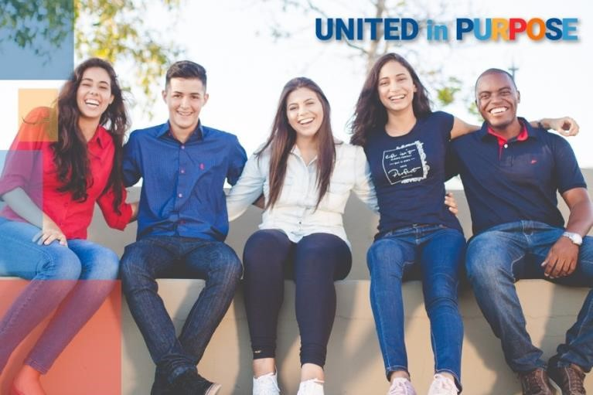

Subject line
Time is running out to become United in Purpose!

Preheader text
[Customize this for the countdown you want to maintain, I.e., one week, few days, today’s the last day!]

Body
Dear [First name],

Whether you are interested in the impact of early literacy, access to dental care for young kids, or creating lasting change in our community, United Way of Snohomish Counyt gives you an opportunity to make a direct impact on the issues you care about.
Through United Way of Snohomish County, you can help advance effective solutions to community challenges making life better for every person across the Snohomish County region.

With United Way of Snohomish County, we can build on [company’s] legacy of service to become United in Purpose. Join us today. [Add link to your campaign landing page].

Closing,
Signature
BUTTON/CTA TEXT: DONATE

Final Email:
United Way Donor: Thank You

From: Your United Way CEO/CPO or Board Chair
Audience: Company employees who donated to United Way (not designated to other organizations) C2A: Live Your Purpose
Image:

Subject line
Thank you! You’ve changed lives in [Anytown region]

Preheader text
Intentionally left blank

Body
Dear [First name],

First, I would like to express my deepest and most heartfelt gratitude for your generous gift to United Way. Your support has a far-reaching impact and will help improve the lives of those in need every day.
I can’t thank you enough for being United in Purpose with us. As someone who has expressed their commitment and intention, I wanted to reach out and let you know that there are additional ways for you to live your purpose and advance the solutions to our community's challenges.
Volunteer. Make a difference in your community through volunteer work – providing a ride for someone who is homebound, reading to preschoolers to get them school-ready, or passing out food to neighbors in need. Perhaps you’d like to serve on one of our community’s grant evaluation boards or offer your professional skills to a local nonprofit in a skilled-volunteering opportunity. There are many ways to contribute your time and skills through United Way.
Advocate. Encourage your neighbors and colleagues to become active in our community and raise your voice on the issues that impact hard-working families in Snohomish County. Be on the lookout for community surveys to help us meet the needs of our community, and join us in making those changes.
Thank you for your commitment to Snohomish County. We are looking forward to working with you to make our community stronger together, United in Purpose.
Closing,
Signature

CTA TEXT: Join us! [Link to website: www.uwsc.org]

