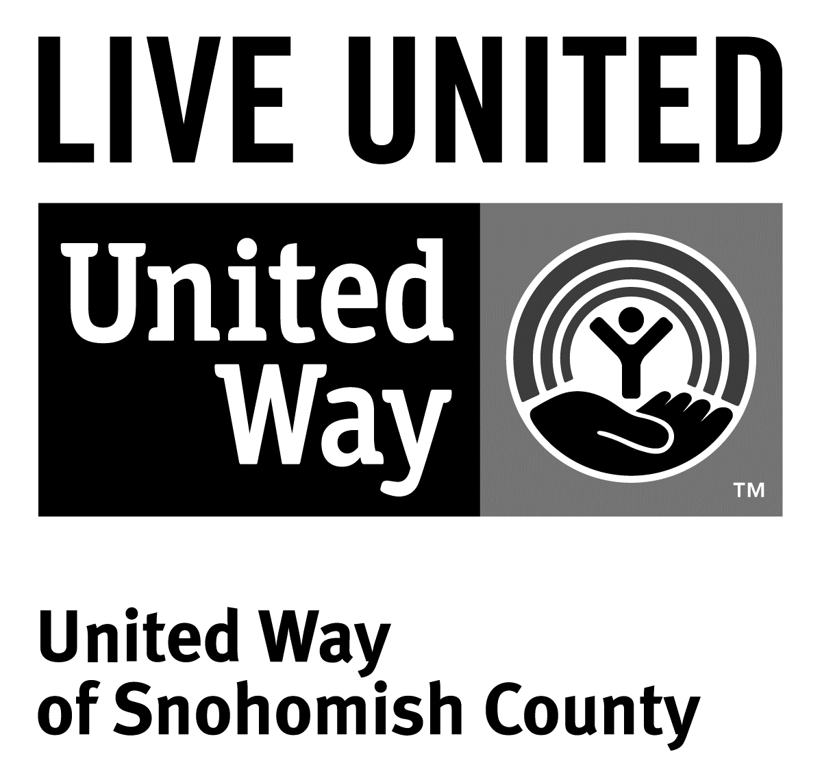
3120 McDougall Ave., Ste. 200
Everett, WA 98201
Ph: 425.374.5500
F: 425.374.5555

FOR IMMEDIATE RELEASE
March 11, 2016

Contact
Jacqui Campbell- 425-374-5501; jacqui.campbell@uwsc.org
Director of Marketing and Communications, United Way of Snohomish County

United Way honors award-winning campaigns

(Everett, WA) – On Wednesday, March 9 more than 300 representatives of Snohomish County companies, nonprofits, school districts, labor unions and government agencies celebrated the close of the 2015 Community Caring Campaign and United Way’s 75th Birthday Celebration at an awards dinner hosted by United Way of Snohomish County.

AT&T of Bothell won the President’s Award in part for increasing their campaign by over 62% over the last four years. They have been nominated or been an award winner six times, and their campaign brings in over $220,000 to make a lasting change in our community. Their employees support the Make a Difference Day Grant—Martin Luther King Day of Caring for Youth and they implement year-round focus on giving back to the community thru support of local food banks, Hopelink, Homeless Connect, and more.

The Labor Partnership Award went to the City of Edmonds. They ran an inclusive and successful campaign that Mayor Dave Earling set the tone of inclusion for and Employee Campaign Manager Carolyn LaFave made sure every voice was heard.

Dr. Fredrika Smith, Superintendent of Monroe Public School District won Executive of the Year Award. She oversaw a campaign that had a 4.2% increase with 80% of their gifts going to our Local Community Fund. Dr. Smith’s messaging and sponsorship was a significant reason for this success and positive change going forward.

“We live in a very generous community.” said Dr. Dennis Smith, the organization’s president and CEO. “Whether we’re talking about large corporations, small family-owned businesses, nonprofits, government agencies or labor unions everyone pulls together to help lift up our community,” he added.

The money raised supports 106 multi-year grants addressing immediate needs in priority investment areas identified by community members and long-term needs through United Way initiatives focusing on education, financial stability and English language learners.

In addition to the money raised through the Community Caring campaign, United Way also raises money for its endowment, seeks grants and works with policymakers to leverage state and federal dollars.

The largest contributions came from The Employees Community Fund of Boeing Puget Sound and The Boeing Company.

Platinum event sponsors included AT&T, Aerospace Machinists District Lodge 751 and The Boeing Company. Premier event sponsors included The Providence Regional Medical Center Everett. Presenting sponsors included Fluke Corporation, Jamco America, Inc. Puget Sound Energy, Tulalip Resort Casino and Union Bank. Media and in-kind sponsors included The Daily Herald, Microsoft, and Stadium Flowers.

Social media posts from the event can be found at www.tagboard.com/UWSC_CCC.

Here is a full list of award winners:

President’s Award
AT&T

Executive of the Year Award
Dr. Fredrika Smith, Monroe School District

Employee Campaign Manager of the Year Awards
Tarah Wilder, Cocoon House
Diane Broderick, Bank of Washington
Cheri Hurst, Rose Howard and Denise Jacobsen, City of Monroe
Amanda Vroman, Housing Hope
Tiffini Schlosser, Lake Stevens School District

Labor Partnership Award
Carolyn LaFave, Todd Court and Diane Cunningham, City of Edmonds

LIVE UNITED Award
Sure Masel and Caryn Walline, Community Transit

Positive Change Award
Leslie Lavoie, City of Mountle Terrace

Best New Campaign
Bob Mundy, CMC Biologics

###

United Way is a community impact organization serving Snohomish County for more than 75 years. United Way of Snohomish County supports a number of initiatives focusing on early learning and education, financial stability for families, a youth program, and North Sound 211.
To find out more about United Way of Snohomish County, including how you can find help, how to volunteer and how United Way serves our community, visit their website at uwsc.org.

