United Way of Snohomish County
Letter of Intent for 2018 Basic Needs Grants

This Word version of the questions is for your use in planning your application. All responses must be submitted through our online application portal; no paper copies will be accepted.

- Program Name
- Agency Name (Auto-Populates)
- Program Category (select): Food, Shelter, Clothing, Health, Transportation
- Point-of-Contact (POC) Name
- POC Title
- POC Phone #
- POC Email Address
- Funding Request Amount (between $10,000 and $50,000)
- Does this request meet the minimum requirements of (1) 100% of households served by this grant will have incomes at or below 250% of Federal Poverty Level, and (2) >51% of households served by this grant are families with young children (0-8)? Select: Yes / No
- Describe the community need you propose to address with these funds. Include any relevant geographic, demographic, language, employment, educational characteristics, data and information. (250 max word count)
- Specifically, how will services be delivered with these funds? (250 max word count)
- Estimate the number of persons to be specifically served with UWSC funds in 2018. Number of persons (unduplicated):
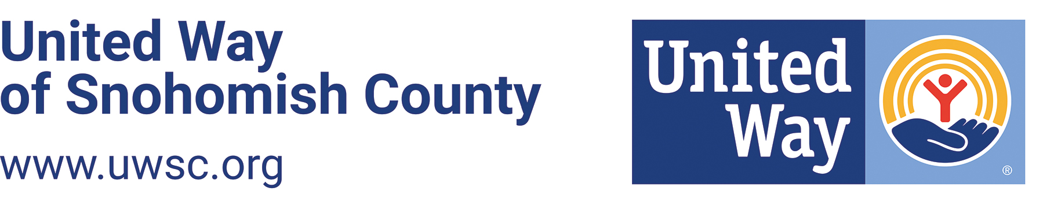
- (Optional) Other comments about your proposal:

